INSIGHTSTREAM: Navigate the NewsLandscape ( React Application)

INTRODUCTION:

PROJECT TITTLE:

INSIGHTSTREAM:Navigate the newslandscape(reactapplication)

In a world of constant change, staying informed is more than a choice—it’s a necessity. InsightSteam is your guide to navigating the evolving landscape of news, trends, and insights. We bridge the gap between information and action, delivering data-driven analysis, expert perspectives, and real-time updates to help you make smarter decisions.

With a commitment to clarity, accuracy, and innovation, InsightSteam transforms complexity into actionable intelligence. Whether you’re tracking industry shifts, market dynamics, or global developments, we empower you to Navigate the Newscape with confidence.

TEAM LEADER:

D.PRAVEEN – ([pp2100448@gmail.com](mailto:pp2100448@gmail.com))

TEAM MEMBERS:

K.RENUKA - (renurenukalai@gmail.com)

M.SANDHIYA- (sandhiyam587@gmail.com)

R.REVATHI - (revathiravathid2004@gmail.com)

* **Project Overview:**

**PURPOSE:**

**Insight Stream News Navigate is a dynamic news aggregation and navigation system designed to help users access categorized, real-time news updates efficiently. It provides a smooth and interactive experience, allowing users to browse, filter, and personalize their news feeds.**

**The News App is a frontend web application designed to deliver the latest news articles from different categories like technology, business, sports, entertainment, and more. The app fetches real-time data from a news API and presents it in a clean, user-friendly interface.**

**FEATURES:**

**✔ News from API Sources: Access a vast library of global news spanning various categories and interests, ensuring a well-rounded coverage of current affairs.**

**✔ Visual News Exploration: Discover breaking stories and explore different news categories through curated image galleries, enhancing the visual appeal of news discovery.**

**✔ Intuitive Design: Navigate the application seamlessly with a clean, modern interface designed for optimal user experience and clarity in information presentation.**

**✔ Advanced Search Feature: Easily access news articles on specific topics through a powerful search feature, providing users with tailored news content based on their interests.**

* **Architecture:**

**1. Component Structure:**

**The News App is built with a modular approach using React components:**

**App.js: The root component, responsible for routing and managing high-level state.**

**Navbar.js: A navigation bar with category links like Technology, Business, Sports, etc.**

**NewsList.js: Fetches and displays a list of news articles. It maps through the data and renders individual news items.**

**NewsItem.js: A reusable component that shows article details — image, title, description, and a "Read More" link.**

**SearchBar.js: Provides search functionality, filtering articles based on user input.**

**. State Management:**

**We’re using React’s built-in useState and useEffect for state handling:**

**Global state:**

**✔ Selected news category.**

**✔Search query.**

**✔Fetched news articles.**

**Local State:**

**✔Component-level states for input values and UI controls.**

**Routing:**

**Routing is managed with react-router-dom, enabling category-based navigation:**

**/ → Home (top headlines)**

**/category/:name → Category-specific news**

**/search → Search results page.**

**4.Setup Instructions:**

**PRE-REQUISITES:**

**Here are the key prerequisites for developing a frontend application using React.js:**

**✔ Node.js and npm:**

**Node.js is a powerful JavaScript runtime environment that allows you to run JavaScript code on the local environment. It provides a scalable and efficient platform for building network applications. Install Node.js and npm on your development machine, as they are required to run JavaScript on the server-side.**

**● Download:** [**https://nodejs.org/en/download/**](https://nodejs.org/en/download/)

**● Installation instructions:** [**https://nodejs.org/en/download/package-manager/**](https://nodejs.org/en/download/package-manager/)

**✔ React.js: React.js is a popular JavaScript library for building user interfaces. It enables developers to create interactive and reusable UI components, making it easier to build dynamic and responsive web applications.**

**Install React.js, a JavaScript library for building user interfaces.**

**● Create a new React app:**

**npx create-react-app my-react-app**

**Replace my-react-app with your preferred project name. ● Navigate to the project directory: cd my-react-app**

**● Running the React App: With the React app created, you can now start the development server and see your React application in action.**

**● Start the development server:**

**npm start**

**This command launches the development server, and you can access your React app at** [**http://localhost:3000**](http://localhost:3000/) **in your web browser.**

**✔ HTML, CSS, and JavaScript: Basic knowledge of HTML for creating the structure of your app, CSS for styling, and JavaScript for client-side interactivity is essential.**

**✔ Version Control: Use Git for version control, enabling collaboration and tracking changes throughout the development process. Platforms like GitHub or Bitbucket can host your repository.**

**• Git: Download and installation instructions can be found at:** [**https://git-scm.com/downloads**](https://git-scm.com/downloads)**.**

**✔ Development Environment: Choose a code editor or Integrated Development Environment (IDE) that suits your preferences, such as Visual Studio Code, Sublime Text, or WebStorm.**

**• Visual Studio Code: Download from** [**https://code.visualstudio.com/download**](https://code.visualstudio.com/download)

**• Sublime Text: Download from** [**https://www.sublimetext.com/download**](https://www.sublimetext.com/download)

**• WebStorm: Download from** [**https://www.jetbrains.com/webstorm/download**](https://www.jetbrains.com/webstorm/download)

**Installation:**

**To install and run the Application project from google drive:**

**Follow below steps:**

**✔ Get the code: • Download the code from the drive link given below:**

**• Navigate into the cloned repository directory and install libraries:**

**cd news-app-react**

**npm install**

**✔ Start the Development Server:**

**• To start the development server, execute the following command: npm start Access the App:**

**• Open your web browser and navigate to** [**http://localhost:3000**](http://localhost:3000/)**.**

**• You should see the applications homepage, indicating that the installation and setup were successful.**

**You have successfully installed and set up the application on your local machine.**

**You can now proceed with further customization, development, and testing as needed.**

**5.Folder Structure:**

**Client:**

**In this project, we’ve split the files into 4 major folders, Components, Context, Pages and Styles. In the pages folder, we store the files that acts as pages at different URLs in the application. The components folder stores all the files, that returns the small components in the application. The context Api will be coded in the context folder. All the styling css files will be stored in the styles folder.**

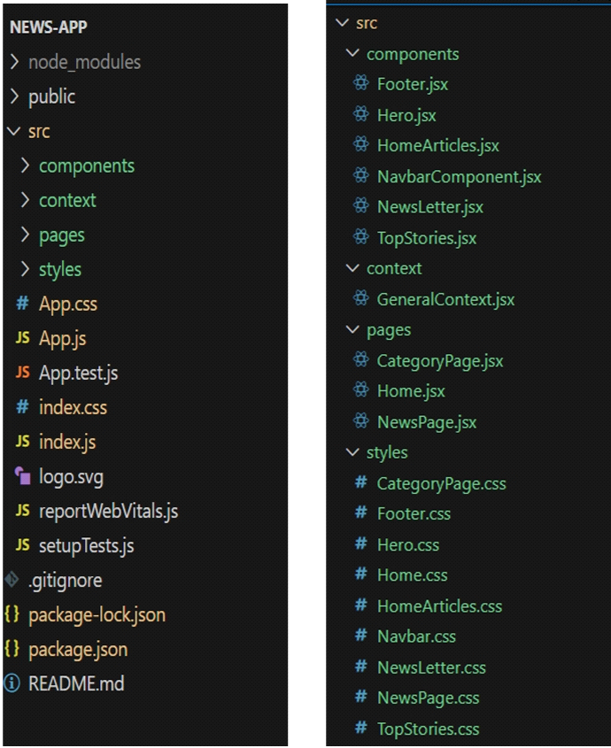

**6.Running the Application:**

**Installation of required tools:**

**To build InsightStream, we'll need a developer's toolkit. We'll use React.js for the interactive interface, React Router Dom for seamless navigation, and Axios to fetch news data.**

**For visual design, we'll choose either Bootstrap or Tailwind CSS for pre-built styles and icons.**

**Open the project folder to install necessary tools. In this project, we use:**

**o React Js**

**o React Router Dom**

**o React Icons**

**o Bootstrap/tailwind css**

**o Axios**

7.**Component documentation**

**1. Key Components:**

**App.js**

**Purpose: Root component that manages routing and global state.**

**Props: None.**

**State:**

**category → Stores the selected news category.**

**searchQuery → Stores the user’s search input.**

**Navbar.js**

**Purpose: Navigation bar for selecting news categories and accessing search.**

**Props:**

**onCategoryChange(category) → Function to set the current category.**

**State: None.**

**NewsList.js**

**Purpose: Fetches and displays a list of news articles.**

**Props:**

**articles → Array of news articles to display.**

**State:**

**loading → Boolean to show a loading indicator while fetching data.**

**NewsItem.js**

**Purpose: Reusable component that displays individual news articles.**

**Props:**

**title → Article headline.**

**description → Short summary of the article.**

**imageUrl → URL of the article’s thumbnail image.**

**newsUrl → Link to the full article.**

**State: None.**

**SearchBar.js**

**Purpose: Allows users to search for news articles by keyword.**

**Props:**

**onSearch(query) → Function to handle search input.**

**State:**

**searchInput → Stores the current value of the search field.**

**2. Reusable Components:**

**Button.js (optional)**

**Purpose: A customizable button used across the app.**

**Props:**

**label → Button text.**

**onClick() → Click event handler.**

**style → Custom inline styles.**

**Loader.js (optional)**

**Purpose: Displays a spinner while content is loading.**

**Props: None.**

**State: None.**

8**.State management**

**We’re using React’s built-in useState and useEffect for state handling:**

**Global state:**

**✔ Selected news category.**

**✔Search query.**

**✔Fetched news articles.**

**Local State:**

**✔Component-level states for input values and UI controls.**

**Routing:**

**Routing is managed with react-router-dom, enabling category-based navigation:**

**/ → Home (top headlines)**

**/category/:name → Category-specific news**

**/search → Search results page**

**9.User Interface**

**Hero components**

**In the hero component, the trending news articles are displayed. It is to highlight**

**them. Apart from that, the search bar is also available to search for various**

**articles and categories.**

**Popular categories**

**In the hero component, the trending news articles are displayed. It is to**

**highlight them. Apart from that, the search bar is also available to search for**

**various articles and categories.**

**Newsletter**

**Staying informed is key! This section would act as a magnet for users who want**

**to stay up-to-date on the latest news. A brief signup form with an email field**

**would be presented, along with a clear call to action button like "Subscribe Now"**

**or "Get Daily News Updates." With a simple click, users can join the**

**InsightStream community and receive curated news delivered straight to their**

**inbox.**

**Category/Search result page**

**Finding the news you crave is effortless with InsightStream. This page displays a**

**neatly organized list of articles matching your chosen category or specific search**

**query. Each entry would provide a clear headline, a concise summary, and if**

**available, an image to give you a quick glimpse into the story. To further refine**

**your exploration, filters or sorting options might be available.**

**Redirected Article page**

**This is where you dive deep! The article page proudly displays the complete**

**news story, retrieved directly from the original source. To keep you engaged and**

**exploring related topics, the page might also suggest additional articles based on**

**the current story. These suggestions can open doors to a world of interconnected**

**information, allowing you to become a well-rounded news connoisseur.**

**10.styling**

**1. CSS Frameworks/Libraries**

**Your current project uses CSS for styling without a framework. However, if you plan to enhance it, you can use CSS frameworks like Tailwind CSS or Bootstrap for better styling and responsiveness.**

**✅ Current CSS Approach**

**Uses plain CSS (style.css) for layout, colors, fonts, and responsiveness.**

**Includes custom styles for homepage, category pages, and recipe details pages.**

**✅ Future Enhancements (Optional)**

**Tailwind CSS – A utility-first CSS framework for faster styling.**

**npm install -D tailwindcss**

**Bootstrap – Provides pre-designed UI components for buttons, cards, and grids.**

**npm install bootstrap**

**2. Theming**

**Currently, the project does not have a dark/light theme switch or a custom design system. However, you can implement:**

**✅ Custom Theming with CSS Variables (Example)**

**:root {**

**--primary-color: #30ac72;**

**--background-color: #f5f5f5;**

**--text-color: #333;**

**}**

**body {**

**background: var(--background-color);**

**color: var(--text-color);**

**}**

**This approach allows easy theme customization without modifying individual styles.**

**11.Testing**

**1. Testing Strategy**

**For a React-based version of My Recipe Book, testing can be divided into three levels:**

**✅ Unit Testing (Jest + React Testing Library)**

**Focuses on individual components to ensure they render correctly.**

**Example: Testing if RecipeCard.js correctly displays a recipe title and image.**

**Example Test for RecipeCard.js**

**import { render, screen } from "@testing-library/react";**

**import RecipeCard from "../components/RecipeCard";**

**test("renders recipe title and image", () => {**

**render(<RecipeCard title="Grilled Cheese" image="/test-img.png" />);**

**expect(screen.getByText("Grilled Cheese")).toBeInTheDocument();**

**expect(screen.getByRole("img")).toHaveAttribute("src", "/test-img.png");**

**});**

**✅ Integration Testing (React Testing Library + Mock Data)**

**Ensures multiple components work together correctly.**

**Example: Testing if clicking a recipe card navigates to the RecipeDetails page.**

**Example Test for CategoryPage.js**

**import { render, screen } from "@testing-library/react";**

**import { MemoryRouter } from "react-router-dom";**

**import CategoryPage from "../pages/CategoryPage";**

**test("renders recipes from a category", () => {**

**render(**

**<MemoryRouter>**

**<CategoryPage categoryType="Meals" />**

**</MemoryRouter>**

**);**

**expect(screen.getByText("Meals")).toBeInTheDocument();**

**});**

**✅ End-to-End (E2E) Testing (Cypress or Playwright)**

**Tests user interactions like clicking buttons, navigating pages, and checking ingredients.**

**Example: Simulating a user searching for a recipe and marking ingredients as used.**

**Example Cypress Test**

**describe("Recipe App User Flow", () => {**

**it("should navigate to a recipe and check ingredients", () => {**

**cy.visit("/");**

**cy.get(".recipe-card").first().click();**

**cy.get("input[type='checkbox']").first().check();**

**});**

**});**

**2. Code Coverage**

**Ensuring that all components and logic are tested properly can be done using Jest’s built-in coverage tool.**

**✅ Run Code Coverage Report**

**npm test -- --coverage**

**This will generate a report showing which parts of the code are covered by tests.**